SNOWFLAKE

CSV Data Loading
& Validation Lab
End-to-end practical documentation with execution screenshots

Lab detail | Value
Platform | Snowflake Snowsight
Role used | SYSADMIN
Database | SNOWFLAKE_LAB_DB
Schema | RAW_DATA
Virtual warehouse | LAB_WH — SMALL
Source file | customers.csv
Destination table | CUSTOMERS
Execution date | 01 November 2026

Outcome: 10 CSV records successfully parsed and loaded, verified, and lab resources cleaned up.

1. Objective and scope
The objective of this practical was to perform a complete CSV ingestion workflow in Snowflake. The exercise covered workspace preparation, database and schema creation, virtual warehouse configuration, target-table definition, CSV file-format configuration, internal-stage creation, file upload, staged-file inspection, COPY INTO ingestion, validation, object inspection, and cleanup.

2. Environment and object layout
Object | Name / configuration | Purpose
Database | SNOWFLAKE_LAB_DB | Container for the lab schema and data objects.
Schema | RAW_DATA | Organizes the target table, stage, and file format.
Warehouse | LAB_WH (SMALL) | Compute resource used to execute the SQL workload.
File format | CSV_FORMAT | Defines how CSV records and dates are parsed.
Internal stage | CSV_STAGE | Stores the uploaded customers.csv file.
Table | CUSTOMERS | Destination table for the ingested records.

The worksheet initially showed the SYSADMIN role and the account's default COMPUTE_WH warehouse. The database and schema were then created and selected. The lab warehouse was created with AUTO_SUSPEND = 60, AUTO_RESUME = TRUE, and INITIALLY_SUSPENDED = TRUE.

3. Workspace and session context
A SQL worksheet named snowflake_csv_ingestion_lab.sql was created in My Workspace. The session context was inspected using CURRENT_USER(), CURRENT_ROLE(), CURRENT_WAREHOUSE(), CURRENT_DATABASE(), and CURRENT_SCHEMA(). The initial result showed SYSADMIN and COMPUTE_WH, with no active database or schema selected.
SELECT
CURRENT_USER() AS USER_NAME,
CURRENT_ROLE() AS ACTIVE_ROLE,
CURRENT_WAREHOUSE() AS ACTIVE_WAREHOUSE,
CURRENT_DATABASE() AS ACTIVE_DATABASE,
CURRENT_SCHEMA() AS ACTIVE_SCHEMA;
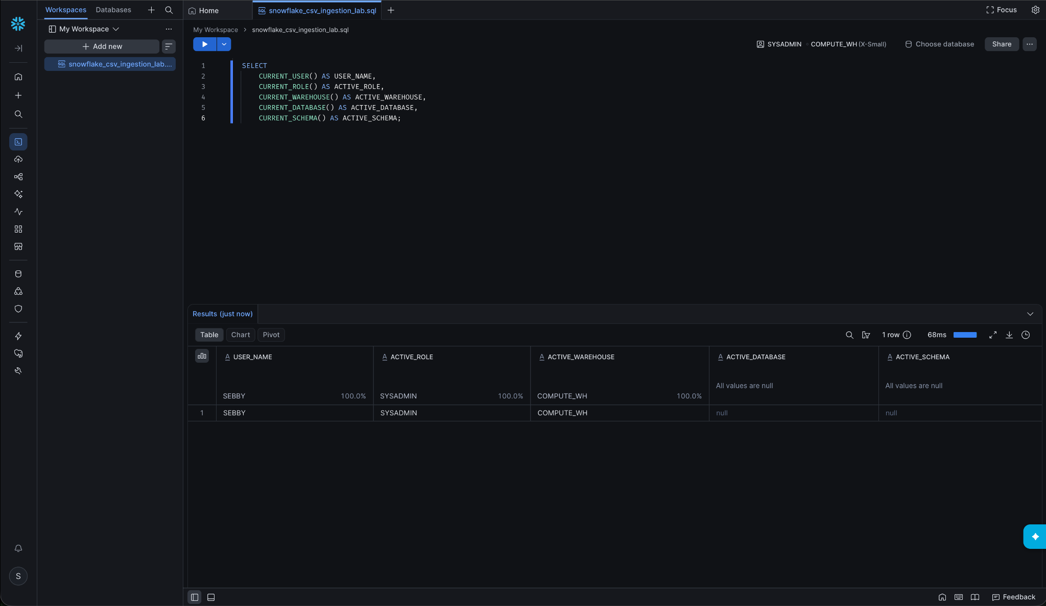
Figure 1. Initial worksheet and session context.
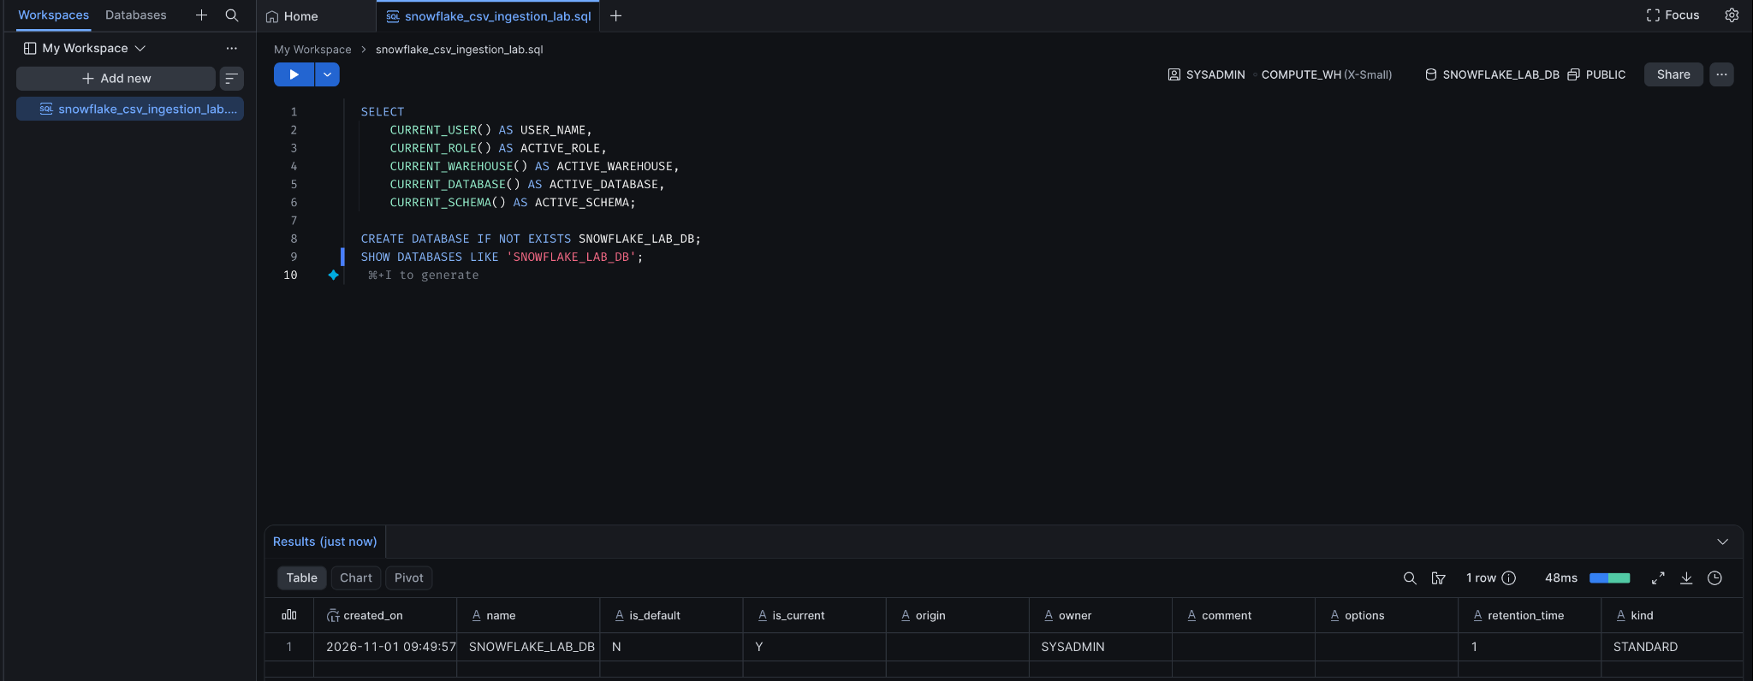
Figure 2. Database creation and SHOW DATABASES verification.
SNOWFLAKE_LAB_DB was created successfully. SHOW DATABASES returned the new database, owned by SYSADMIN.

4. Database and schema creation
CREATE DATABASE IF NOT EXISTS SNOWFLAKE_LAB_DB;
CREATE SCHEMA IF NOT EXISTS SNOWFLAKE_LAB_DB.RAW_DATA;
USE DATABASE SNOWFLAKE_LAB_DB;
USE SCHEMA RAW_DATA;
SHOW SCHEMAS IN DATABASE SNOWFLAKE_LAB_DB;
SELECT CURRENT_DATABASE(), CURRENT_SCHEMA();
The schema listing showed the built-in INFORMATION_SCHEMA and PUBLIC schemas as well as the newly created RAW_DATA schema. The session context query confirmed SNOWFLAKE_LAB_DB and RAW_DATA as the active database and schema.
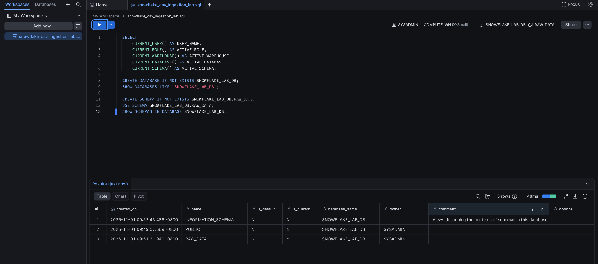
Figure 3. Creation and verification of RAW_DATA.
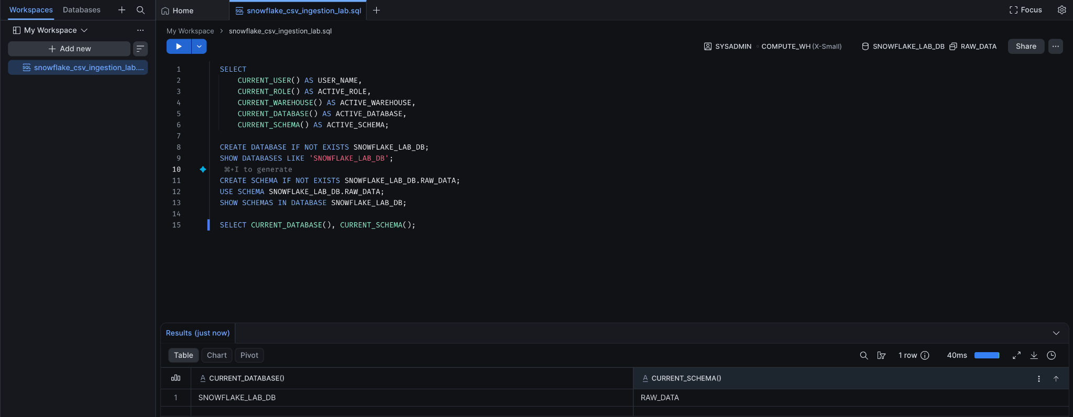
Figure 4. Session context confirms SNOWFLAKE_LAB_DB and RAW_DATA.

5. Virtual warehouse provisioning
CREATE WAREHOUSE LAB_WH
WAREHOUSE_SIZE = 'SMALL'
AUTO_SUSPEND = 60
AUTO_RESUME = TRUE
INITIALLY_SUSPENDED = TRUE;
USE WAREHOUSE LAB_WH;
SHOW WAREHOUSES LIKE 'LAB_WH';
LAB_WH was created as a SMALL standard warehouse. Its initial state was SUSPENDED, which is consistent with INITIALLY_SUSPENDED = TRUE. AUTO_SUSPEND was set to 60 seconds and AUTO_RESUME was enabled. When subsequent SQL work required compute, the warehouse resumed and the later SHOW WAREHOUSES output showed its state as STARTED.
Parameter | Configured value | Meaning
WAREHOUSE_SIZE | SMALL | Compute size selected for this practical.
AUTO_SUSPEND | 60 | Suspend after 60 seconds of inactivity.
AUTO_RESUME | TRUE | Resume automatically when a query needs the warehouse.
INITIALLY_SUSPENDED | TRUE | Create the warehouse in a suspended state.

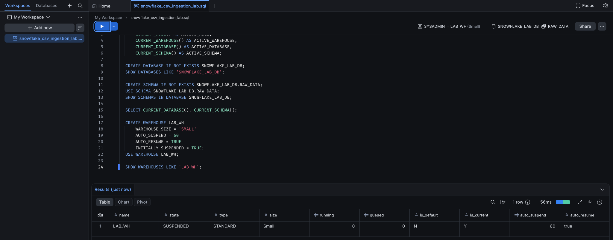
Figure 5. LAB_WH creation and initial SUSPENDED state.
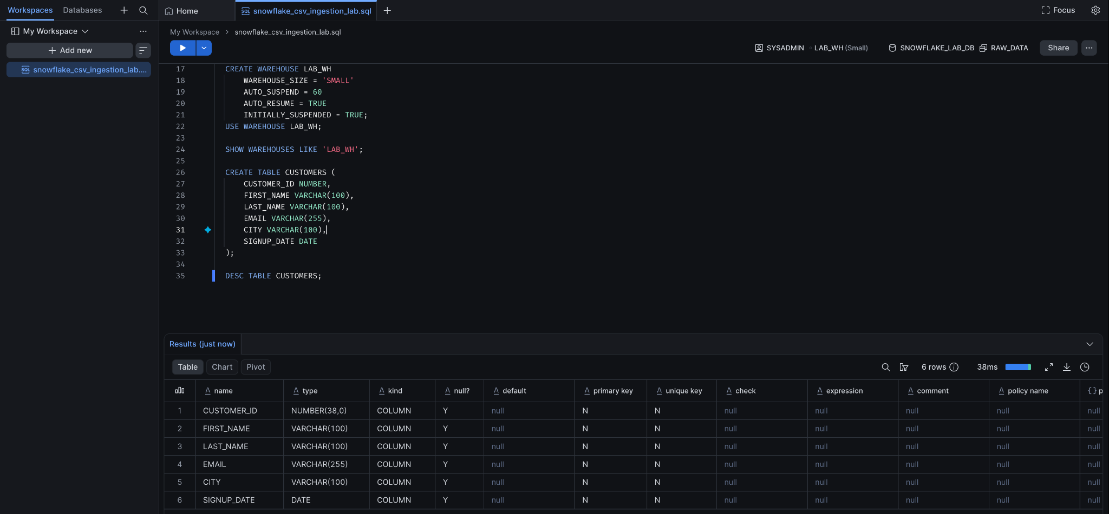
Figure 6. CUSTOMERS table creation and DESCRIBE TABLE output.

6. Destination table definition
The CUSTOMERS table was created in SNOWFLAKE_LAB_DB.RAW_DATA. DESCRIBE TABLE confirmed six columns and their Snowflake data types.
CREATE TABLE CUSTOMERS (
CUSTOMER_ID NUMBER,
FIRST_NAME VARCHAR(100),
LAST_NAME VARCHAR(100),
EMAIL VARCHAR(255),
CITY VARCHAR(100),
SIGNUP_DATE DATE
);
DESC TABLE CUSTOMERS;
Column | Data type | Description
CUSTOMER_ID | NUMBER(38,0) | Customer identifier
FIRST_NAME | VARCHAR(100) | Customer first name
LAST_NAME | VARCHAR(100) | Customer last name
EMAIL | VARCHAR(255) | Customer email address
CITY | VARCHAR(100) | Customer city
SIGNUP_DATE | DATE | Customer signup date

The DESCRIBE output showed all six columns as nullable. No primary-key or unique constraint was defined as part of this loading exercise.

7. CSV file format configuration
CREATE FILE FORMAT CSV_FORMAT
TYPE = CSV
FIELD_DELIMITER = ','
SKIP_HEADER = 1
FIELD_OPTIONALLY_ENCLOSED_BY = '"'
DATE_FORMAT = 'YYYY-MM-DD'
EMPTY_FIELD_AS_NULL = TRUE;
SHOW FILE FORMATS LIKE 'CSV_FORMAT';
CSV_FORMAT was created in the RAW_DATA schema. It specifies comma-separated fields, one header row to skip, optional double-quote enclosure, YYYY-MM-DD date parsing, and conversion of empty fields to NULL.
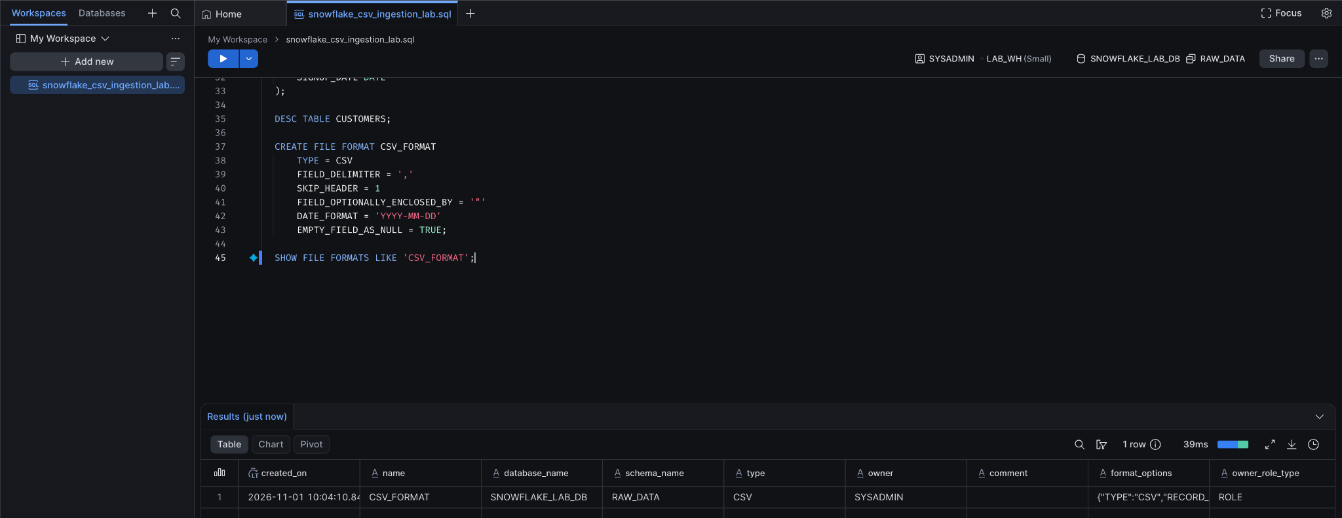
Figure 7. CSV_FORMAT creation and SHOW FILE FORMATS result.

8. Internal stage creation and inspection
CREATE STAGE CSV_STAGE
FILE_FORMAT = CSV_FORMAT;
SHOW STAGES LIKE 'CSV_STAGE';
DESC STAGE CSV_STAGE;
CSV_STAGE was created as an internal named stage in the RAW_DATA schema. Its stage-level file-format property references CSV_FORMAT. DESC STAGE confirmed the configured STAGE_FILE_FORMAT / FORMAT_NAME value.
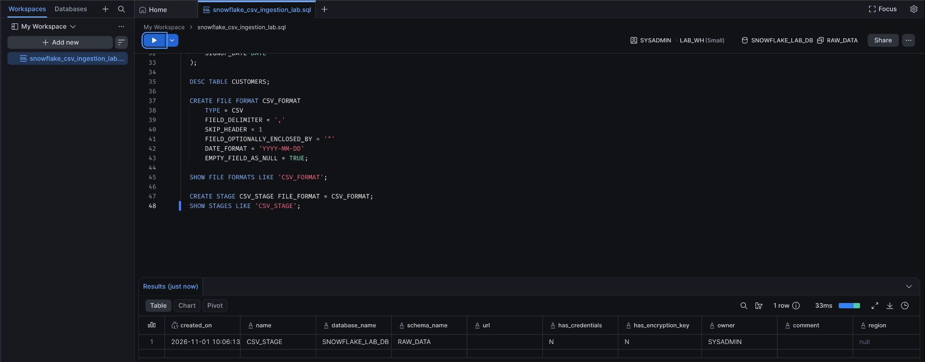
Figure 8. CSV_STAGE creation and SHOW STAGES verification.
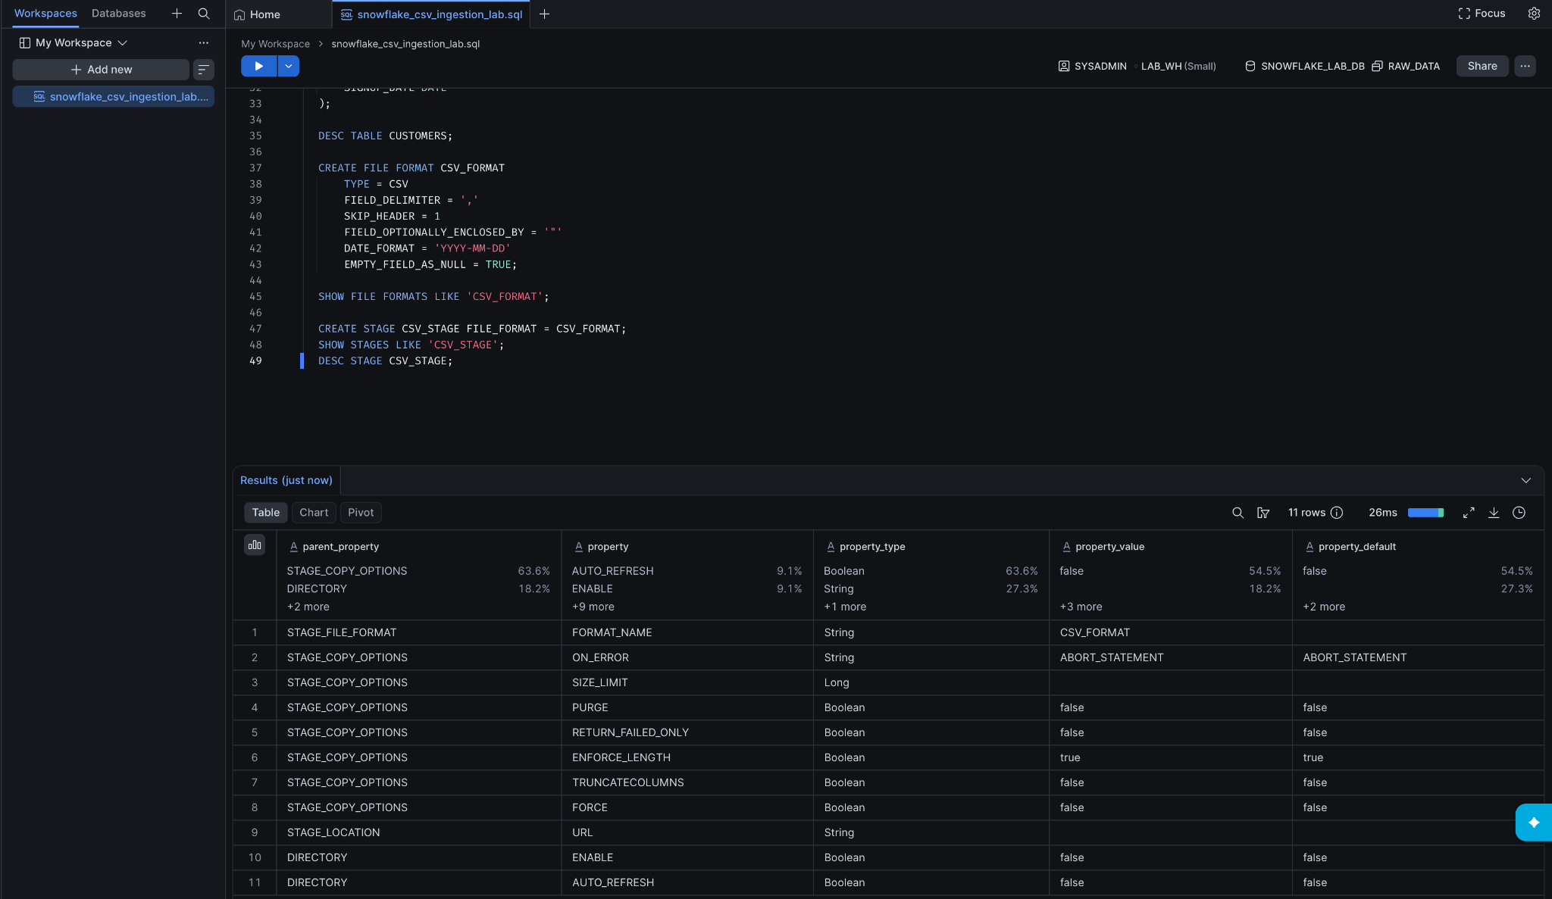
Figure 9. DESC STAGE confirms CSV_FORMAT association.

9. CSV upload and staged-file verification
The customers.csv file was uploaded to CSV_STAGE using the Snowsight stage upload workflow. The LIST command confirmed that the file was present. The returned object path was csv_stage/customers.csv, with a reported size of 608 bytes.
LIST @CSV_STAGE;
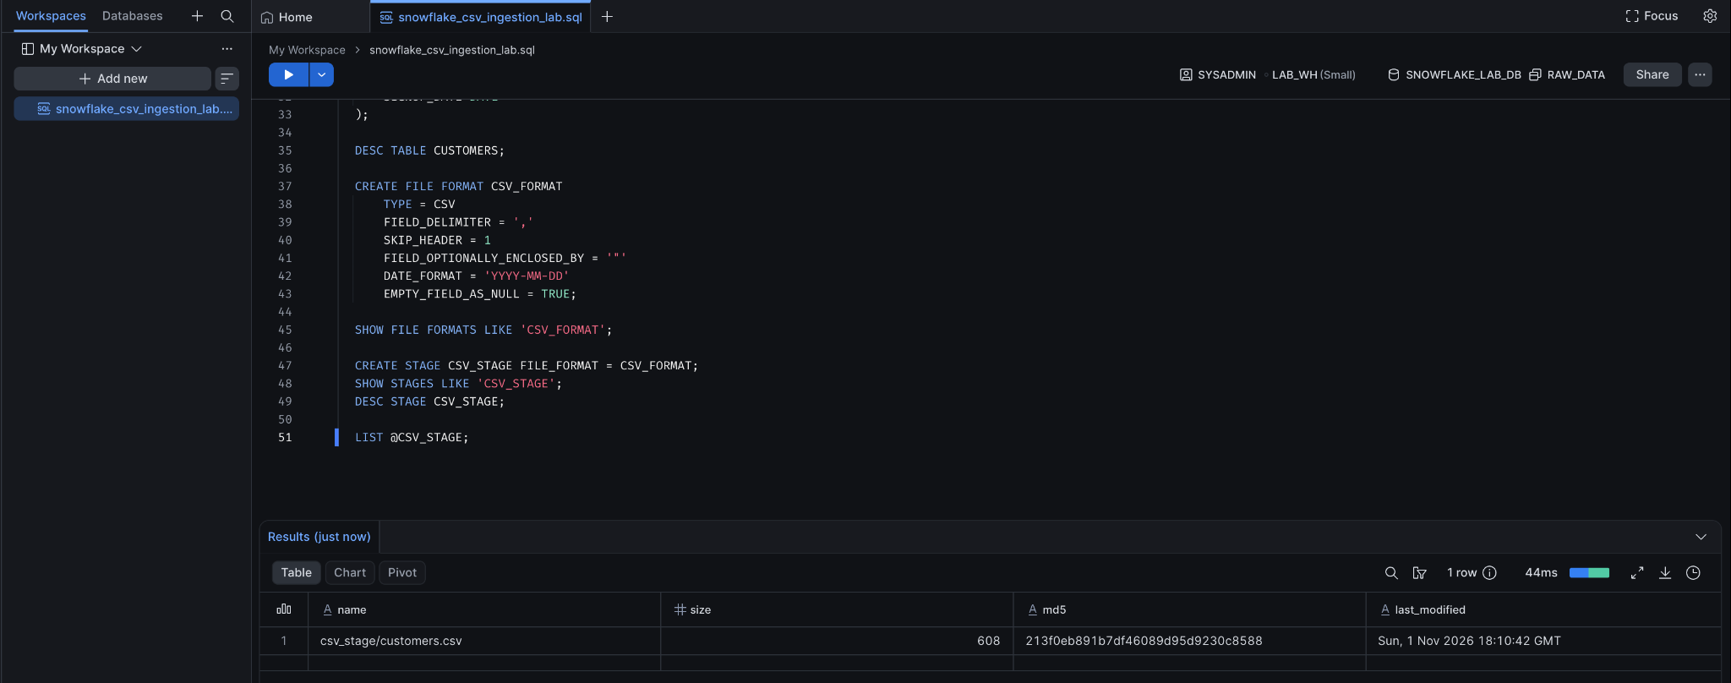
Figure 10. LIST @CSV_STAGE confirms customers.csv is staged.

10. Inspecting the staged CSV
Before loading the data into the destination table, a SELECT query read the staged file using CSV_FORMAT. Positional fields $1 through $6 were aliased to the expected customer column names. The result displayed ten data records, with the header excluded by SKIP_HEADER = 1.
SELECT
$1 AS CUSTOMER_ID,
$2 AS FIRST_NAME,
$3 AS LAST_NAME,
$4 AS EMAIL,
$5 AS CITY,
$6 AS SIGNUP_DATE
FROM @CSV_STAGE
(FILE_FORMAT => 'CSV_FORMAT');
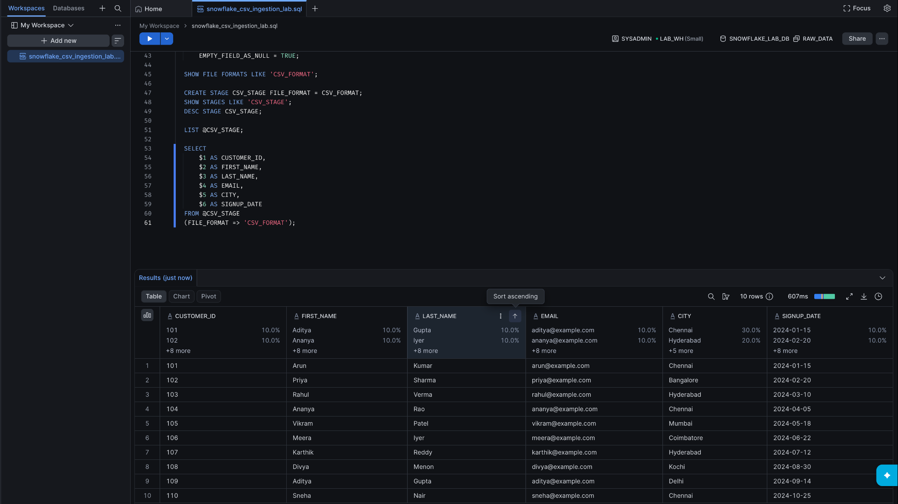
Figure 11. Staged-file preview returns ten parsed customer records.

11. Loading data with COPY INTO
COPY INTO loaded the staged CSV into CUSTOMERS. An explicit destination-column list was used. The SELECT statement read the six positional fields from the stage and cast them to the destination types. ON_ERROR = 'ABORT_STATEMENT' instructed Snowflake to fail the statement if a load error was encountered.
COPY INTO CUSTOMERS
(
CUSTOMER_ID,
FIRST_NAME,
LAST_NAME,
EMAIL,
CITY,
SIGNUP_DATE
)
FROM
(
SELECT
$1::NUMBER,
$2::VARCHAR,
$3::VARCHAR,
$4::VARCHAR,
$5::VARCHAR,
$6::DATE
FROM @CSV_STAGE
)
FILE_FORMAT = (FORMAT_NAME = 'CSV_FORMAT')
ON_ERROR = 'ABORT_STATEMENT';
The COPY INTO result reported status LOADED, 10 rows parsed, 10 rows loaded, and 0 errors. The first-error fields were NULL, indicating that no load error was reported.
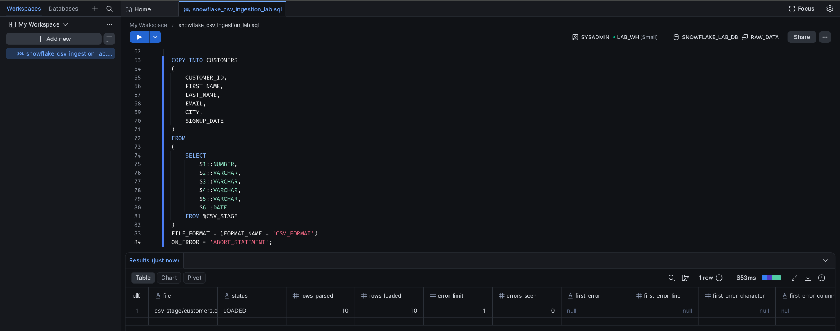
Figure 12. COPY INTO result: LOADED, 10 rows parsed, 10 rows loaded, zero errors.

12. Data validation
A COUNT(*) query returned 10 records. SELECT * FROM CUSTOMERS displayed all ten customer records, with the expected six columns and parsed signup dates.
SELECT COUNT(*) AS TOTAL_RECORDS
FROM CUSTOMERS;
SELECT *
FROM CUSTOMERS
ORDER BY CUSTOMER_ID;
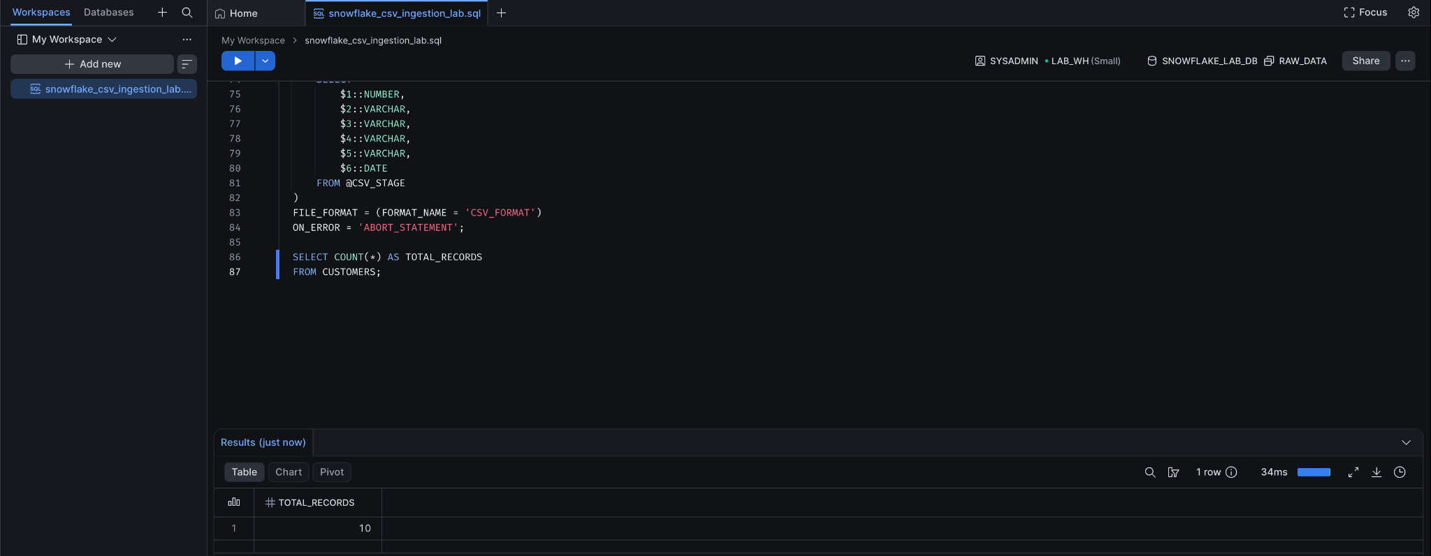
Figure 13. Record-count validation returns 10.
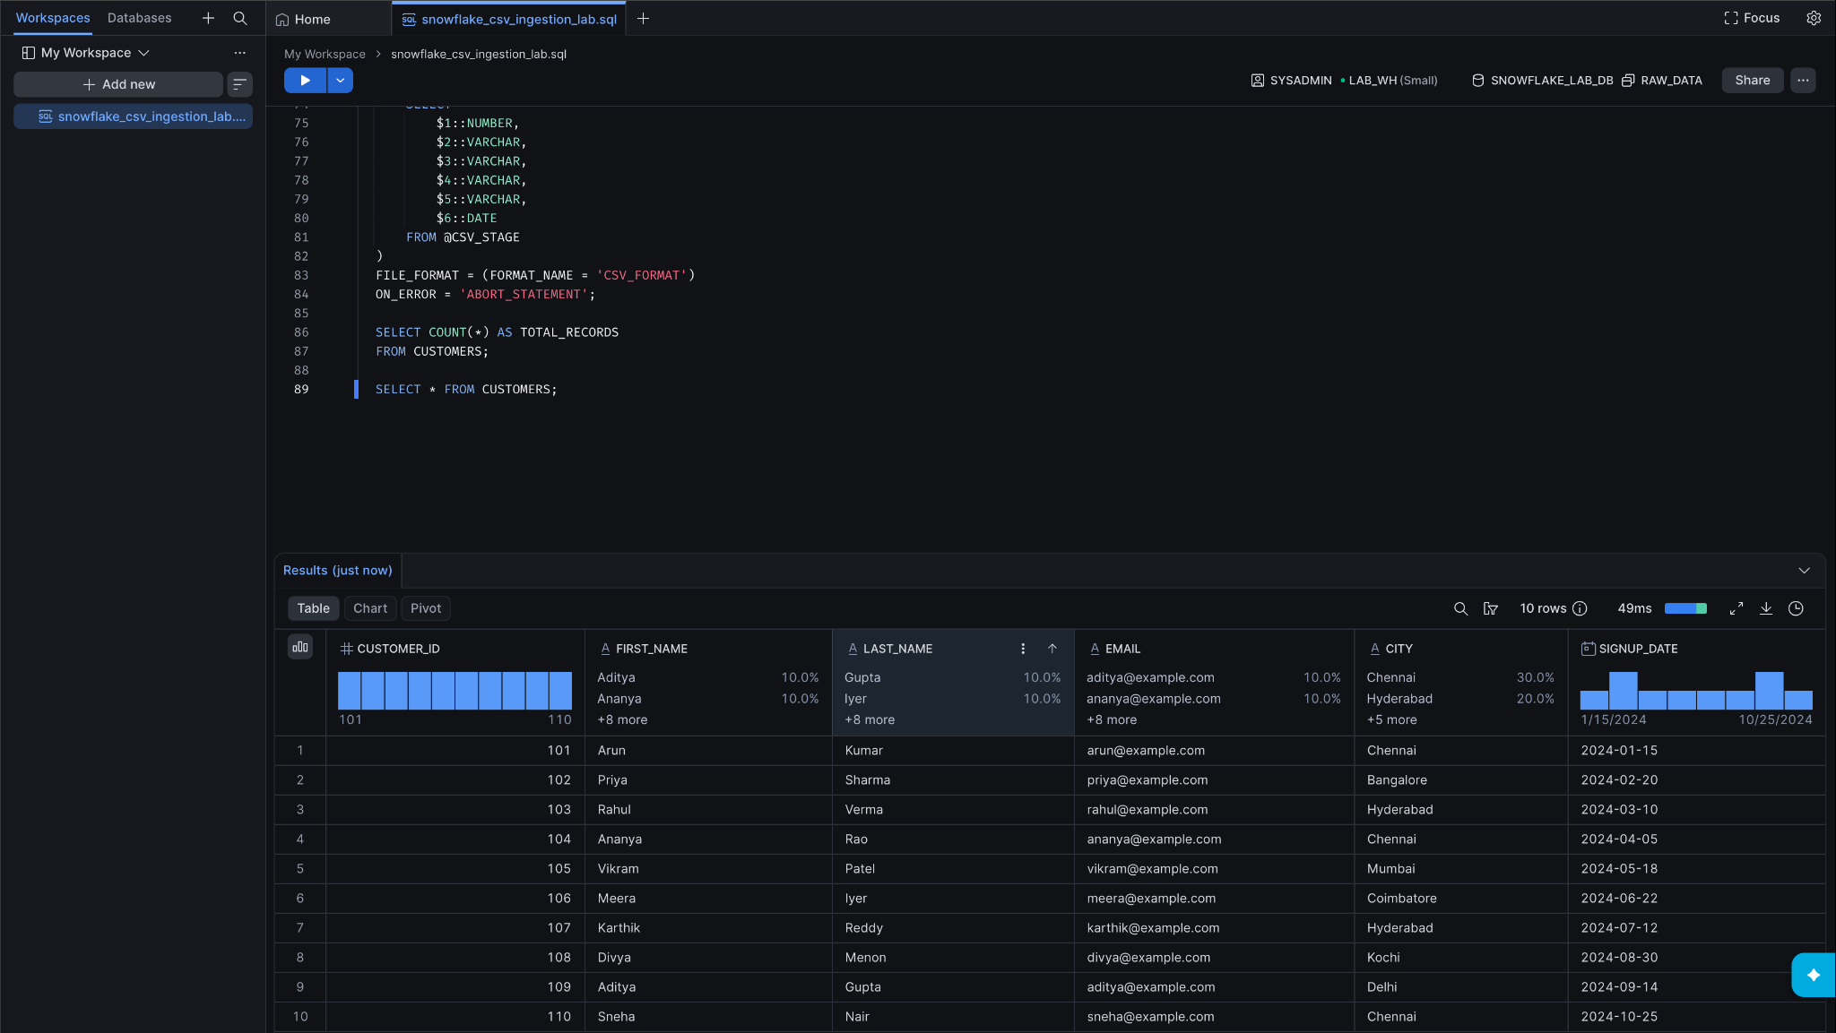
Figure 14. CUSTOMERS table displays the ten loaded records.

13. Snowflake object verification
SHOW DATABASES;
SHOW SCHEMAS IN DATABASE SNOWFLAKE_LAB_DB;
SHOW TABLES IN SCHEMA SNOWFLAKE_LAB_DB.RAW_DATA;
SHOW STAGES IN SCHEMA SNOWFLAKE_LAB_DB.RAW_DATA;
SHOW FILE FORMATS IN SCHEMA SNOWFLAKE_LAB_DB.RAW_DATA;
SHOW WAREHOUSES;
The object-verification commands were executed to inspect the database, schema, table, stage, file format, and warehouse. The warehouse listing showed LAB_WH in STARTED state at that point, because the workload had resumed it.
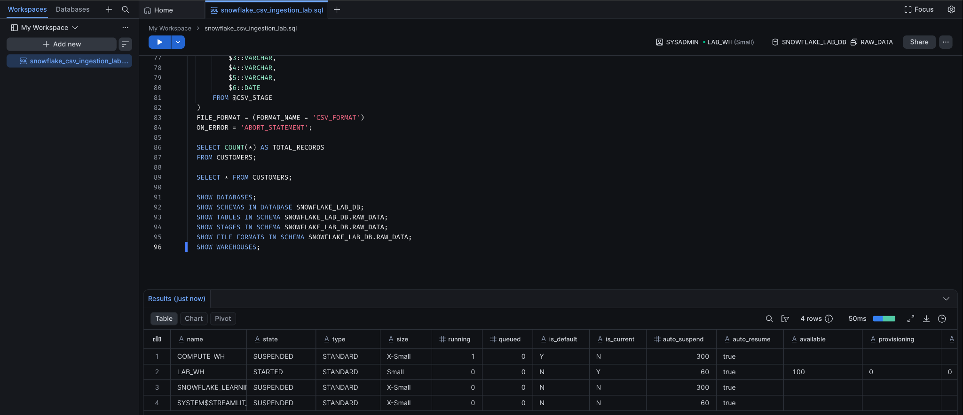
Figure 15. Object verification commands and warehouse listing.

14. Cleanup and resource removal
The staged CSV file was removed first. The table, stage, and file format were then dropped, followed by the RAW_DATA schema and SNOWFLAKE_LAB_DB database. Finally, LAB_WH was suspended and dropped. The final SHOW WAREHOUSES output no longer included LAB_WH.
REMOVE @CSV_STAGE;
DROP TABLE IF EXISTS CUSTOMERS;
DROP STAGE IF EXISTS CSV_STAGE;
DROP FILE FORMAT IF EXISTS CSV_FORMAT;
DROP SCHEMA IF EXISTS RAW_DATA;
DROP DATABASE IF EXISTS SNOWFLAKE_LAB_DB;
-- Suspend only if the warehouse is running.
ALTER WAREHOUSE LAB_WH SUSPEND;
DROP WAREHOUSE IF EXISTS LAB_WH;
Note: In this run, the staged file removal returned 'removed'. The final warehouse listing contained the account's other warehouses but no LAB_WH. The database and its child objects were removed by the DROP DATABASE operation.
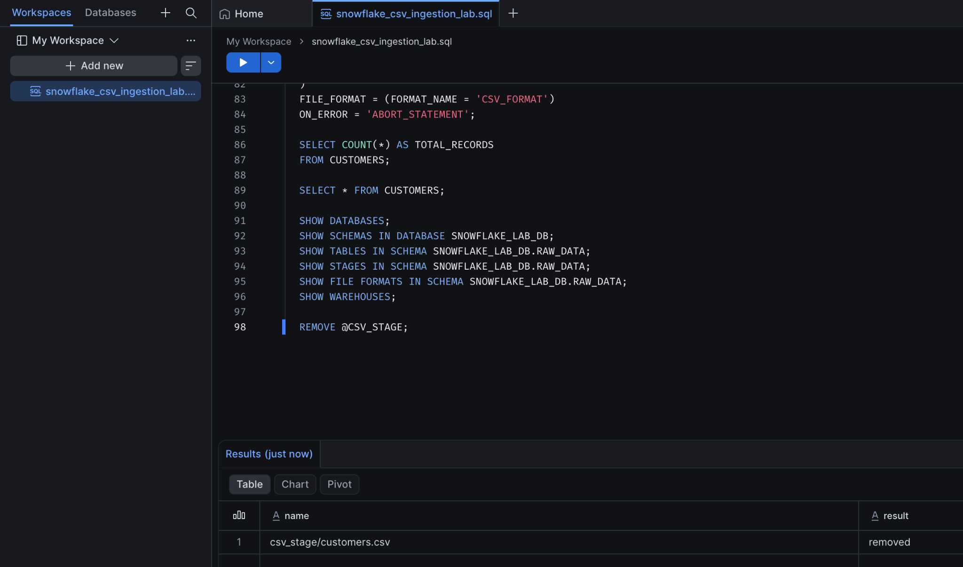
Figure 16. REMOVE @CSV_STAGE confirms the staged file was removed.
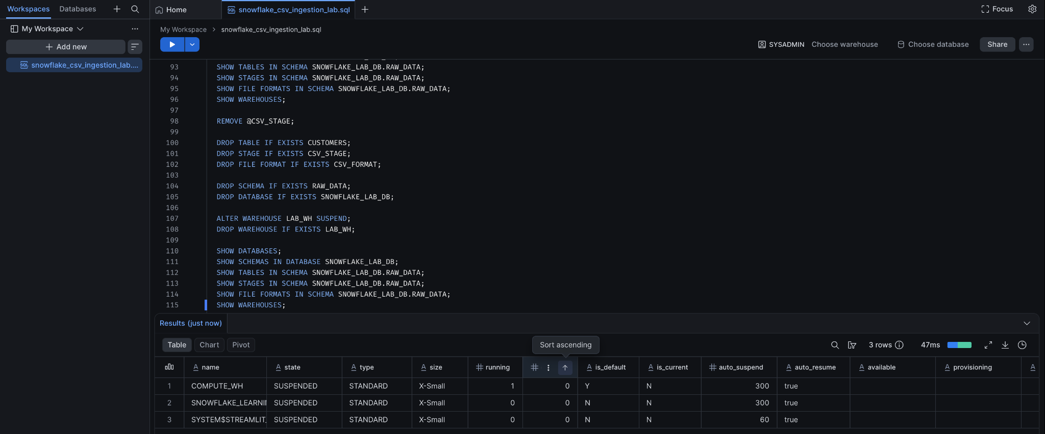
Figure 17. Final cleanup script and warehouse listing without LAB_WH.

15. Results and outcome
Validation | Observed result
Database and schema | SNOWFLAKE_LAB_DB and RAW_DATA created and selected
Warehouse | LAB_WH created as SMALL; auto-suspend 60 seconds; auto-resume enabled
Table definition | CUSTOMERS created with six columns
File format | CSV_FORMAT created and associated with CSV_STAGE
Stage upload | customers.csv listed in the internal stage
Staged-file preview | 10 data rows returned
COPY INTO | LOADED; 10 rows parsed; 10 rows loaded; 0 errors
Table validation | COUNT(*) returned 10
Cleanup | Staged file, lab database objects, and LAB_WH removed

The practical successfully demonstrated an end-to-end Snowflake CSV ingestion workflow: provisioning Snowflake objects, configuring CSV parsing, uploading a file to an internal stage, previewing staged data, loading records with COPY INTO, validating the result, and cleaning up the lab resources.

16. Key concepts learned
- A database and schema organize Snowflake data objects; they do not provide query compute.
- A virtual warehouse supplies compute for SQL execution and can automatically suspend and resume.
- A file format defines how staged files are parsed; a stage stores files for loading.
- A staged file can be queried with positional references such as $1, $2, and $3.
- COPY INTO supports explicit destination-column mapping and typed transformations from staged data.
- The COPY INTO result provides file-level load status, parsed/loaded row counts, and error details.
- Warehouse suspension and warehouse deletion are different lifecycle operations.

Appendix: Final lab SQL script
The statements below summarize the main SQL workflow. The file upload itself was performed through Snowsight, not through this SQL script.
-- 1. Database and schema
CREATE DATABASE IF NOT EXISTS SNOWFLAKE_LAB_DB;
CREATE SCHEMA IF NOT EXISTS SNOWFLAKE_LAB_DB.RAW_DATA;
USE DATABASE SNOWFLAKE_LAB_DB;
USE SCHEMA RAW_DATA;
-- 2. Warehouse
CREATE WAREHOUSE LAB_WH
WAREHOUSE_SIZE = 'SMALL'
AUTO_SUSPEND = 60
AUTO_RESUME = TRUE
INITIALLY_SUSPENDED = TRUE;
USE WAREHOUSE LAB_WH;
-- 3. Destination table
CREATE TABLE CUSTOMERS (
CUSTOMER_ID NUMBER,
FIRST_NAME VARCHAR(100),
LAST_NAME VARCHAR(100),
EMAIL VARCHAR(255),
CITY VARCHAR(100),
SIGNUP_DATE DATE
);
DESC TABLE CUSTOMERS;
-- 4. File format and stage
CREATE FILE FORMAT CSV_FORMAT
TYPE = CSV
FIELD_DELIMITER = ','
SKIP_HEADER = 1
FIELD_OPTIONALLY_ENCLOSED_BY = '"'
DATE_FORMAT = 'YYYY-MM-DD'
EMPTY_FIELD_AS_NULL = TRUE;
CREATE STAGE CSV_STAGE FILE_FORMAT = CSV_FORMAT;
LIST @CSV_STAGE;
-- 5. Preview staged data
SELECT $1, $2, $3, $4, $5, $6
FROM @CSV_STAGE
(FILE_FORMAT => 'CSV_FORMAT');
-- 6. Load data
COPY INTO CUSTOMERS
(
CUSTOMER_ID, FIRST_NAME, LAST_NAME,
EMAIL, CITY, SIGNUP_DATE
)
FROM (
SELECT
$1::NUMBER, $2::VARCHAR, $3::VARCHAR,
$4::VARCHAR, $5::VARCHAR, $6::DATE
FROM @CSV_STAGE
)
FILE_FORMAT = (FORMAT_NAME = 'CSV_FORMAT')
ON_ERROR = 'ABORT_STATEMENT';
-- 7. Validate
SELECT COUNT(*) FROM CUSTOMERS;
SELECT * FROM CUSTOMERS ORDER BY CUSTOMER_ID;
-- 8. Cleanup
REMOVE @CSV_STAGE;
DROP DATABASE IF EXISTS SNOWFLAKE_LAB_DB;
DROP WAREHOUSE IF EXISTS LAB_WH;

